Hurwitz zeta function

Intro

A kind of zeta function.

It is always defined with complex variables s with Res(x) and a is NOT a nonegative integer.

Def

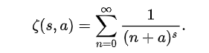

Property

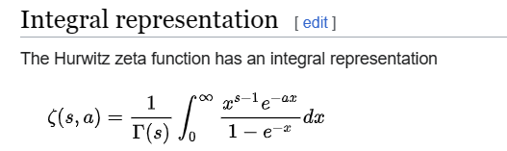



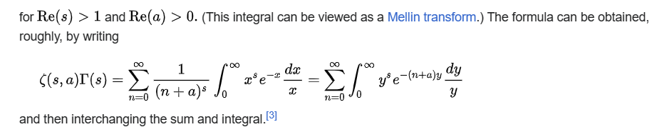

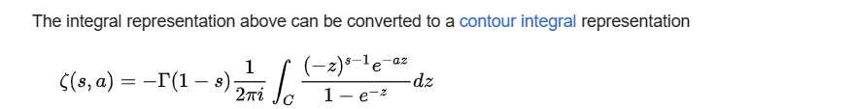

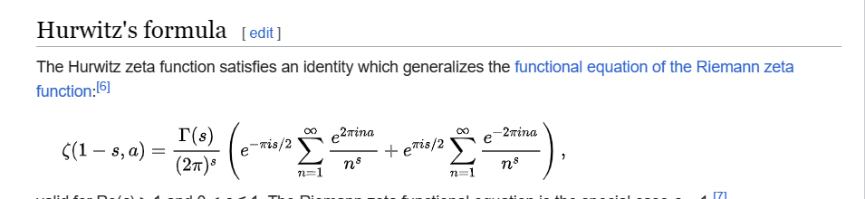

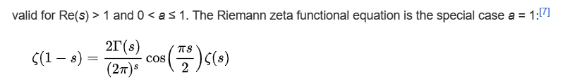

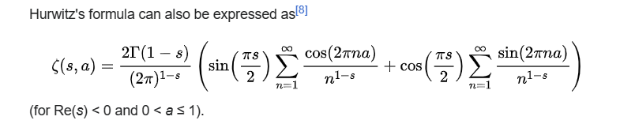

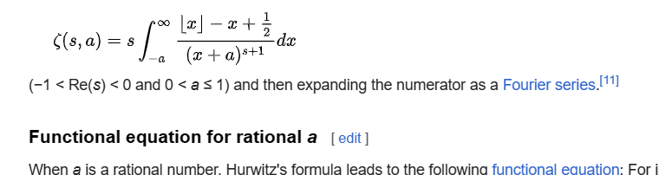

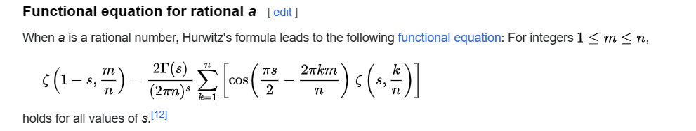

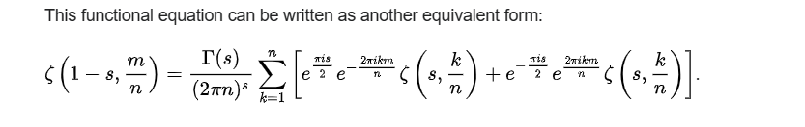

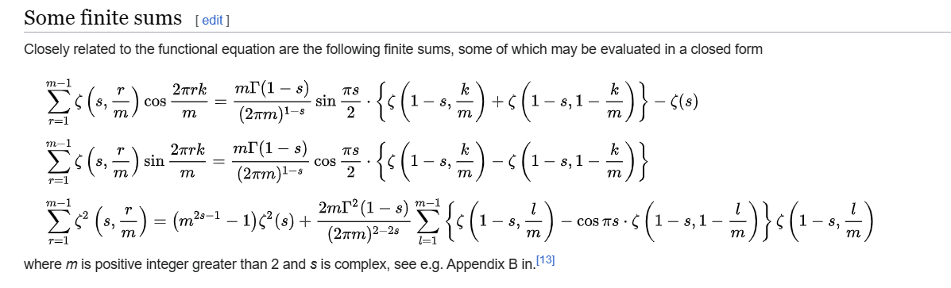

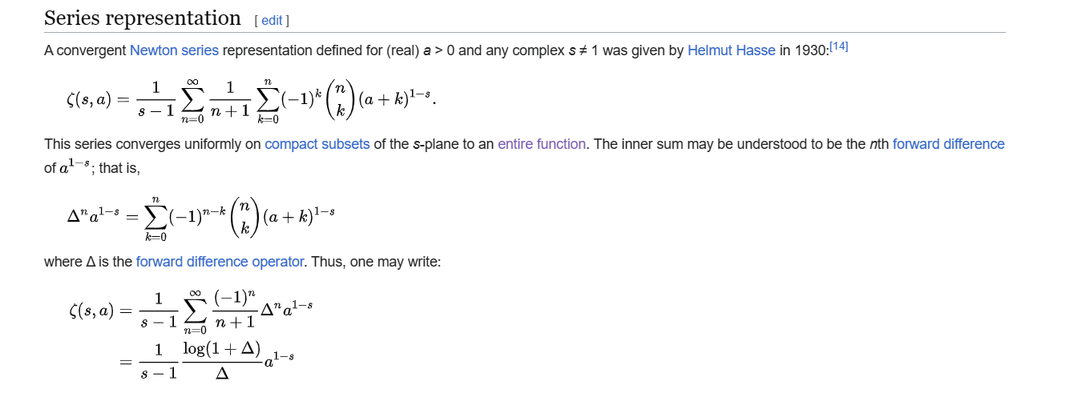

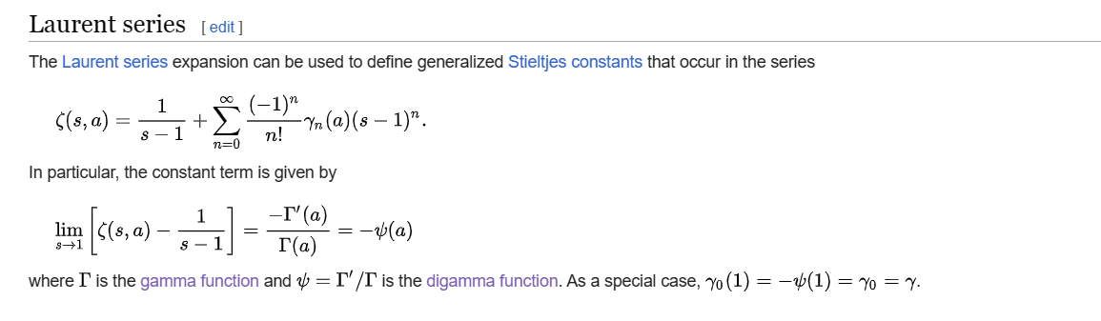

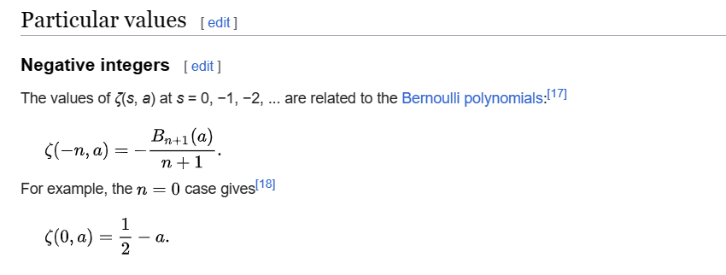

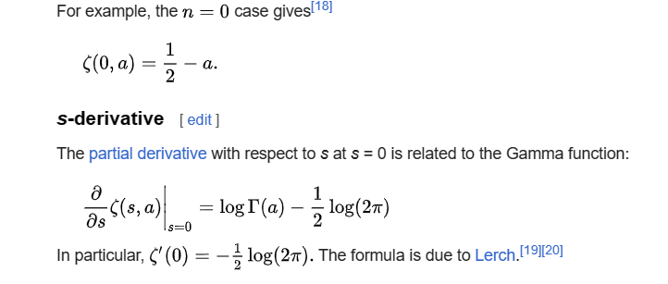

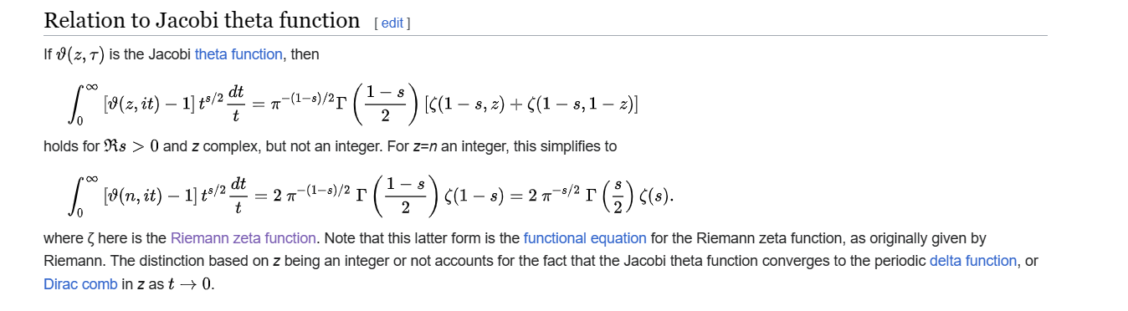

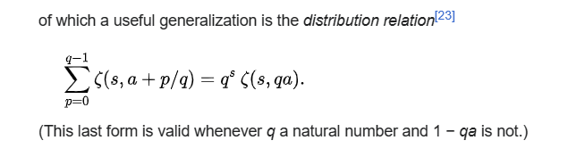

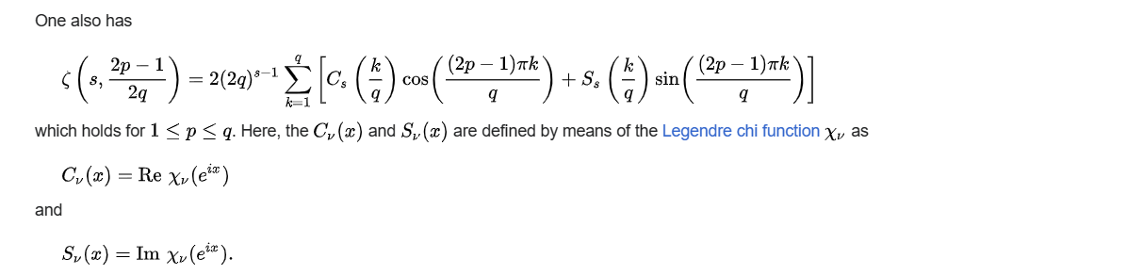

Ref

[Hurwitz zeta function - Wikipedia](https://en.wikipedia.org/wiki/Hurwitz_zeta_function)